39 Gordon Street, Huntly, Aberdeenshire AB54 8EQ

Telephone: 01466 792627 Fax: 01466 794962

VETERINARY SURGEONS
STRATHBOGIE VETERINARY CENTRE LTD

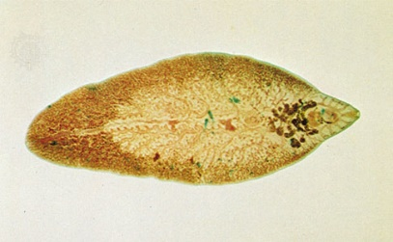Liver fluke costs the sheep and cattle industry in the UK around £23 million per year! This is through reduced growth rates/daily liveweight gains as well as condemning of carcases/livers at the abattoir. Due to the warmer and drier summer experienced this year there should be less fluke about – however this does not mean that there will not be a problem and it is something that should be treated / monitored. The lifecycle of the fluke is dependent on a few things; warmth, wet ground, and the presence of the snail where they spend part of their lives and of course the animals to ingest them. So after munching away and ingestion by the host, the metacercariae (young underdeveloped flukes) develop within the small intestine and then migrate through the abdomen of the animal to then invade the liver capsule reaching the bile duct after six to eight weeks. Egg-laying adults will have developed 10-12 weeks after ingestion. As only the adult fluke lay eggs – which can be picked up on faecal egg counts (which we can do in house) this does not mean that the presence of zero eggs mean there is no fluke present.
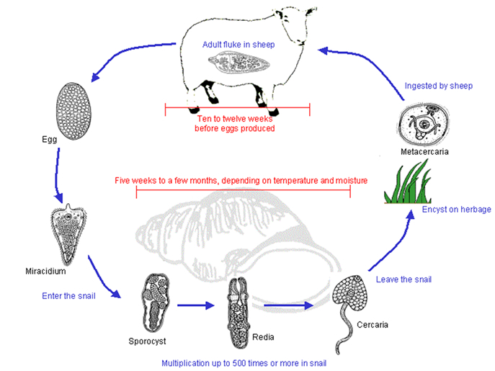
http://www.scops.org.uk/internal-parasites/liver-fluke/lifecycle/

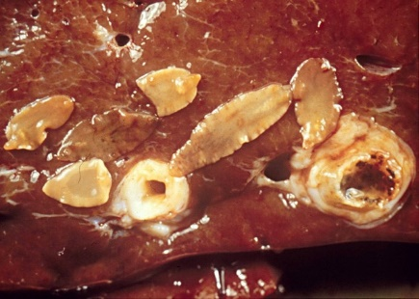Both cattle and sheep do not build an immunity to fluke (unlike other parasites where older animals are less commonly affected) so require treatments throughout there lives. However just when everything seemed simple regarding treatment… here comes the problem… RESISTANCE! Resistance is being seen more commonly in Triclabendazole products – so treatment should be targeted at certain times of year with this product. Treatment involves administering a drench/injection (combination wormer/fluke drenches are also available). So when is best to treat? Well this depends on a few things; the type of cattle/sheep and also the drug being used. Cattle are much less likely to succumb to acute fluke – this in sheep often presents as sudden death after ingesting a large amount of juveniles which all bombard the liver at once and is seen early autumn. Cattle are more likely to suffer from chronic faciolasis – caused by the adult fluke. Clinical signs are; persistent diarrhoea, chronic weight loss despite adequate feeding and anaemia (paleness, fatigue). For cattle – we recommend the following regimes. In areas of high fluke numbers we would recommend treating at housing and then again 8 weeks later. However due to the (hopefully!) lower numbers around this year, treat 8 weeks post housing with any of the following drugs; Closantel, Nitroxynil, Triclabendazole (pour on). The following drugs; Albendazole, Clorsulon, oxyclozanide can be done 12 weeks post housing. The difference in timing is due to the stages of flukes which are killed by the drug. Basically our aim is to ensure that we kill the fluke present so; levels do not affect productivity and also to kill off adult fluke so when we turn out the cattle again in the spring we are not immediately infecting the pasture with eggs. As mentioned before sheep suffer from acute, subacute and chronic fasciolasis. Again with chronic fluke signs are the same as cattle. High levels of fluke will no doubt affect productivity once more and also conception rates. Tupping is a high risk time for fluke in sheep – autumn or winter so treatment would be recommended around this time. Please be aware there are some products which recommend drenching is not done around this time – endospec (albendazole is one of them). Abattoir records are really useful for assessing disease on farm as findings from the post mortem should be reported back to you.
As an aside you may be seeing rumen fluke being identified at post mortem or at the abattoir. The rumen fluke shouldn’t be causing illness/disease like liver fluke do. They initially reside in the small intestine (so can see some diarrhoea signs then) and then go to the rumen. Oxyclozanide is the only flukicide that also kills rumen fluke.
Thank you to everyone that came to the ‘Responsible Antibiotic Use’ Meeting at the beginning of the month. There were some useful points made, and hopefully over time we can all aim to do our bit to reduce antibiotic use. Following on from this… the dreaded health plans. We are recommending that you take the time to produce a health plan with us on a yearly basis. Health plans look at a number of things; presence of disease/illness, antibiotic and vaccine use as well as births and losses on the farm. They can be a useful tool for future planning and seeing where things are going both well and where things are going wrong and how measures can be put in place to help rectify this. Health plans also are required for farm assurance schemes. Keeping good records of treatments, births/stillborns/deaths definitely helps when making plans and allows are more accurate representation of the farm. If you would like to go over or produce a health plan then please get in touch and book a visit or come in for a chat.

